Security

Butler Lampson

TECS Week 2005
January 2005

Outline
Introduction: what is security?
Principals, the “speaks for” relation, and chains of responsibility
Secure channels and encryption
Names and groups
Authenticating systems
Authorization
Implementation

REAL-WORLD SECURITY
It’s about value, locks, and punishment.
  - Locks good enough that bad guys don’t break in very often.
  - Police and courts good enough that bad guys that do break in get caught and punished often enough.
  - Less interference with daily life than value of loss.

Security is expensive—buy only what you need.
  - People do behave this way
  - We don’t tell them this—a big mistake
  - Perfect security is the worst enemy of real security

Elements of Security
Policy: Specifying security
What is it supposed to do?
Mechanism: Implementing security
How does it do it?
Assurance: Correctness of security
Does it really work?

Abstract Goals for Security
Secrecy controlling who gets to read information
Integrity controlling how information changes or resources are used
Availability providing prompt access to information and resources
Accountability knowing who has had access to information or resources

Dangers
Dangers
Vandalism or sabotage that
  - damages information integrity
  - disrupts service availability
Theft of money integrity
Theft of information secrecy
Loss of privacy secrecy

Vulnerabilities

Vulnerabilities
  - Bad (buggy or hostile) programs
  - Bad (careless or hostile) people
giving instructions to good programs
  - Bad guys corrupting or eavesdropping on communications

Threats
  - Adversaries that can and want to exploit vulnerabilities

Defensive strategies
Coarse: Isolate—Keep everybody out
  - Disconnect
Medium: Exclude—Keep the bad guys out
  - Code signing, firewalls
Fine: Restrict—Let the bad guys in, but keep them from doing damage
  - Hardest to implement
  - Sandboxing, access control
Recover—Undo the damage. Helps with integrity.
  - Backup systems, restore points
Punish—Catch the bad guys and prosecute them
  - Auditing, police

Assurance
Trusted Computing Base (TCB)
  - Everything that security depends on
  - Must get it right
  - Keep it small and simple
Elements of TCB
  - Hardware
  - Software
  - Configuration
Defense in depth

Assurance: Defense in Depth
Network, with a firewall
Operating system, with sandboxing
  - Basic OS (such as NT)
  - Higher-level OS (such as Java)
Application that checks authorization directly

All need authentication

TCB Examples
Policy: Only outgoing Web access
TCB: firewall allowing outgoing port 80 TCP connections, but no other traffic
Hardware, software, and configuration

Policy: Unix users can read system directories, and read and write their home directories
TCB: hardware, Unix kernel, any program that can write a system directory (including any that runs as superuser).
Also /etc/passwd, permissions on all directories.

TCB: Configuration
Done again for each system, unlike HW or SW
  - New chance for mistakes each time
Done by amateurs, not experts
  - No learning from experience
  - Little training

Needs to be very simple
  - At the price of flexibility, fine granularity

Making Configuration Simple
Users—keep it simple
  - At most three levels: self, friends, others
Three places to put objects
  - Everything else done automatically with policies
Administrators—keep it simple
  - Work by defining policies. Examples:
Each user has a private home folder
Each user in one workgroup with a private folder
System folders contain vendor-approved releases
All executable programs signed by a trusted party
Today’s systems don’t support this very well

Assurance: Configuration Control
It’s 2 am. Do you know what software is running on your machine?
Secure configuration ⇒ some apps don’t run
  - Hence must be optional: “Secure my system”
  - Usually used only in an emergency
Affects the entire configuration
  - Software: apps, drivers, macros
  - Access control: shares, authentication
Also need configuration audit

Why We Don’t Have “Real” Security
A. People don’t buy it
  - Danger is small, so it’s OK to buy features instead.
  - Security is expensive.
Configuring security is a lot of work.
Secure systems do less because they’re older.
  - Security is a pain.
It stops you from doing things.
Users have to authenticate themselves.

B. Systems are complicated, so they have bugs.
  - Especially the configuration

“Principles” for Security
Security is not formal
Security is not free
Security is fractal

Abstraction can’t keep secrets
  - “Covert channels” leak them

It’s all about lattices

ELEMENTS OF SECURITY
Policy: Specifying security
What is it supposed to do?
Mechanism: Implementing security
How does it do it?
Assurance: Correctness of security
Does it really work?

Specify: Policies and Models

Policy — specifies the whole system informally.
Secrecy Who can read information?
Integrity Who can change things, and how?
Availability How prompt is the service?

Model—specifies just the computer system, but does so precisely.
Access control model guards control access
to resources.
Information flow model classify information, prevent disclosure.

Implement: Mechanisms and Assurance

Mechanisms — tools for implementation.
Authentication Who said it?
Authorization Who is trusted?
Auditing What happened?

Trusted computing base.
Keep it small and simple.
Validate each component carefully.

Information flow model
(Mandatory security)
A lattice of labels for data:
  - unclassified < secret < top secret;
  - public < personal < medical < financial
label( f (x)) = max(label( f ), label(x))
Labels can keep track of data properties:
  - how secret Secrecy
  - how trustworthy Integrity
When you use (release or act on) the data, user needs a ≥ clearance

Access Control Model
Guards control access to valued resources.
Reference monitor

Object
Do
operation
Resource
Principal
Guard
Request
Source
Audit log
Authentication
Authorization

Access Control
Guards control access to valued resources.

Structure the system as —
Objects entities with state.
Principals can request operations
on objects.
Operations how subjects read or change objects.
Reference monitor

Object
Do
operation
Resource
Principal
Guard
Request
Source
Audit log
Authentication
Authorization

Access Control Rules

Rules control the operations allowed
for each principal and object.

Principal may do | Operation on | Object
Taylor | Read | File “Raises”
Lampson | Send “Hello” | Terminal 23
Process 1274 | Rewind | Tape unit 7
Schwarzkopf | Fire three shots | Bow gun
Jones | Pay invoice 432 | Account Q34

Mechanisms—The Gold Standard
Authenticating principals
  - Mainly people, but also channels, servers, programs (encryption makes channels, so key is a principal)
Authorizing access
  - Usually for groups, principals that have some property, such as “Microsoft employee” or “type-safe” or “safe for scripting”
Auditing

Assurance
  - Trusted computing base

Standard Operating System Security
Assume secure channel from user (without proof)
Authenticate user by local password
  - Assign local user and group SIDs
Access control by ACLs: lists of SIDs and permissions
  - Reference monitor is the OS, or any RPC target
Domains: same, but authenticate by RPC to controller
Web servers: same, but simplified
  - Establish secure channel with SSL
  - Authenticate user by local password (or certificate)
  - ACL on right to enter, or on user’s private state

NT Domain Security
Just like OS except for authentication
OS does RPC to domain for authentication
  - Secure channel to domain
  - Just do RPC(user, password) to get user’s SIDs
Domain may do RPC to foreign domain
  - Pairwise trust and pairwise secure channels
  - SIDs include domain ID, so a domain can only authenticate its own SIDs

Web Security Today
Server: Simplified from single OS
  - Establish secure channel with SSL
  - Authenticate user by local password (or certificate)
  - ACL on right to enter, or on user’s private state
Browser (client): Basic authentication
  - Of server by DNS lookup, or by SSL + certificate
  - Of programs by supplier’s signature
Good programs run as user
Bad ones rejected or totally sandboxed

END-TO-END EXAMPLE
Alice is at Intel, working on Atom, a joint Intel-Microsoft project
Alice connects to Spectra, Atom’s web page, with SSL
says
K_{SSL}
says
says
Alice’s smart card
Alice’s login system
Spectra
web page
K_{temp}
Alice@Intel
Atom@Microsoft
Microsoft
Intel
K_{Alice}
Spectra ACL

Chain of responsibility
Alice at Intel, working on Atom, connects to Spectra, Atom’s web page, with SSL
Chain of responsibility:
K_{SSL} ⇒ K_{temp} ⇒ K_{Alice}
⇒ Alice@Intel ⇒ Atom@Microsoft ⇒ Spectra
says
K_{SSL}
says
says
Alice’s smart card
Alice’s login system
Spectra
web page
K_{temp}
Alice@Intel
Atom@Microsoft
Microsoft
Intel
K_{Alice}
Spectra ACL

Principals

Authentication: Who sent a message?

Authorization: Who is trusted?

Principal — abstraction of “who”:
People Lampson, Taylor
Machines VaxSN12648, Jumbo
Services SRC-NFS, X-server
Groups SRC, DEC-Employees
Roles Taylor as Manager
Joint authority Taylor and Lampson
Weakening Taylor or UntrustedProgram
Channels Key #7438

Theory of Principals

Principal says statement P says s
Lampson says “read /SRC/Lampson/foo”
SRC-CA says “Lampson’s key is #7438”

Axioms
If A says s and A says (s implies s') then A says s'
If A = B then (A says s) = (B says s)

The “Speaks for” Relation ⇒

Principal A speaks for B about T A ⇒T B
If A says something in set T, B does too:
Thus, A is stronger than B, or responsible for B, about T
Precisely: (A says s) ∧ (s ∈ T) implies (B says s)
These are the links in the chain of responsibility

Examples
Alice ⇒ Atom group of people
Key #7438 ⇒ Alice key for Alice

Delegating Authority

How do we establish a link in the chain: a fact Q ⇒ R

The “verifier” of the link must see evidence, of the form
“P says Q ⇒ R”
There are three questions about this evidence
  - How do we know that P says the delegation?
  - Why do we trust P for this delegation?
  - Why is P willing to say it?

How Do We Know P says X?
If P is | then
a key | P signs X cryptographically
some other channel | message X arrives on channel P
the verifier itself | X is an entry in a local database
These are the only ways that the verifier can directly know who said something: receive it on a secure channel or store it locally
Otherwise we need C ⇒ P, where C is one of these cases
  - Get this by recursion

Why Do We Trust The Delegation?

We trust A to delegate its own authority.

Delegation rule: If P says Q ⇒ R then Q ⇒ R
Reasonable if P is competent and accessible.

Why Is P Willing To Delegate To Q?
Some facts are installed manually
  - KIntel ⇒ Intel, when Intel and Microsoft establish a direct relationship
  - The ACL entry Lampson ⇒ usr/Lampson
Others follow from the properties of some algorithm
  - If Diffie-Hellman yields KDH, then I can say
“K_{DH} ⇒ me, provided
You are the other end of the K_{DH} run
You don’t disclose K_{DH} to anyone else
You don’t use K_{DH} to send anything yourself.”
In practice I simply sign K_{DH} ⇒ K_{me}

Why Is P Willing To Delegate To Q?
Others follow from the properties of some algorithm
  - If server S starts process P from and sets up a channel C from P, it can say C ⇒ SQLv71
Of course, only someone who believes S ⇒ SQLv71 will believe this
To be conservative, S might compute a strong hash H_{SQLv71} of SQLv71.exe and require
Microsoft says “H_{SQLv71} ⇒ SQLv71”
before authenticating C

Chain of responsibility
Alice at Intel, working on Atom, connects to Spectra, Atom’s web page, with SSL
Chain of responsibility:
K_{SSL} ⇒ K_{temp} ⇒ K_{Alice}
⇒ Alice@Intel ⇒ Atom@Microsoft ⇒ Spectra
says
K_{SSL}
says
says
Alice’s smart card
Alice’s login system
Spectra
web page
K_{temp}
Alice@Intel
Atom@Microsoft
Microsoft
Intel
K_{Alice}
Spectra ACL

Authenticating Channels
Chain of responsibility:
KSSL | ⇒ | Ktemp | ⇒ | KAlice | ⇒ | Alice@Intel | ⇒ ...
Ktemp says |  | KAlice says
(SSL setup) |  | (via smart card)
says
K_{SSL}
says
says
Alice’s smart card
Alice’s login system
Spectra
web page
K_{temp}
Alice@Intel
Atom@Microsoft
Microsoft
Intel
K_{Alice}
Spectra ACL

Authenticating Names: SDSI
A name is in a name space, defined by a principal P
  - P is like a directory. The root principals are keys.
Rule: P speaks for any name in its name space
KIntel ⇒ Intel ⇒ Intel/Alice (= Alice@Intel)
says
K_{SSL}
says
says
Alice’s smart card
Alice’s login system
Spectra
web page
K_{temp}
Alice@Intel
Atom@Microsoft
Microsoft
Intel
K_{Alice}
Spectra ACL

Authenticating Names
KIntel ⇒ Intel ⇒ Intel/Alice (= Alice@Intel)
Ktemp | ⇒ | KAlice | ⇒ | Alice@Intel | ⇒ ...
 |  | KIntel says
says
K_{SSL}
says
says
Alice’s smart card
Alice’s login system
Spectra
web page
K_{temp}
Alice@Intel
Atom@Microsoft
Microsoft
Intel
K_{Alice}
Spectra ACL

Authenticating Groups
A group is a principal; its members speak for it
  - Alice@Intel Þ Atom@Microsoft
  - Bob@Microsoft Þ Atom@Microsoft
  - …
Evidence for groups: Just like names and keys.
KMicrosoft ⇒ Microsoft Þ Microsoft/Atom
(= Atom@Microsoft)
says
K_{SSL}
says
says
Alice’s smart card
Alice’s login system
Spectra
web page
K_{temp}
Alice@Intel
Atom@Microsoft
Microsoft
Intel
K_{Alice}
Spectra ACL

Authenticating Groups
KMicrosoft ⇒ Microsoft Þ Atom@Microsoft
... ⇒ | KAlice | ⇒ | Alice@Intel | ⇒ | Atom@Microsoft | ⇒ ...
 |  |  | KMicrosoft says
says
K_{SSL}
says
says
Alice’s smart card
Alice’s login system
Spectra
web page
K_{temp}
Alice@Intel
Atom@Microsoft
Microsoft
Intel
K_{Alice}
Spectra ACL

Authorization with ACLs
View a resource object O as a principal
P on O’s ACL means P can speak for O
  - Permissions limit the set of things P can say for O
If Spectra’s ACL says Atom can r/w, that means
Spectra says Atom@Microsoft ⇒r/w Spectra
says
K_{SSL}
says
says
Alice’s smart card
Alice’s login system
Spectra
web page
K_{temp}
Alice@Intel
Atom@Microsoft
Microsoft
Intel
K_{Alice}
Spectra ACL

Authorization with ACLs
Spectra’s ACL says Atom can r/w
...⇒ | Alice@Intel | ⇒ | Atom@Microsoft | ⇒r/w | Spectra
 |  |  | Spectra says
says
K_{SSL}
says
says
Alice’s smart card
Alice’s login system
Spectra
web page
K_{temp}
Alice@Intel
Atom@Microsoft
Microsoft
Intel
K_{Alice}
Spectra ACL

End-to-End Example: Summary
Request on SSL channel: KSSL says “read Spectra”
Chain of responsibility:
K_{SSL} ⇒ K_{temp} ⇒ K_{Alice}
⇒ Alice@Intel ⇒ Atom@Microsoft ⇒ Spectra
says
K_{SSL}
says
says
Alice’s smart card
Alice’s login system
Spectra
web page
K_{temp}
Alice@Intel
Atom@Microsoft
Microsoft
Intel
K_{Alice}
Spectra ACL

Compatibility with Local OS?
(1) Put network principals on OS ACLs
(2) Let network principal speak for local one
  - Alice@Intel ⇒ Alice@microsoft
  - Use network authentication
replacing local or domain authentication
  - Users and ACLs stay the same
(3) Assign SIDs to network principals
  - Do this automatically
  - Use network authentication as before

Summaries
The chain of responsibility can be long
Ktemp says KSSL ⇒ Ktemp
KAlice says Ktemp ⇒ KAlice
KIntel says KAlice ⇒ Alice@Intel
KMicrosoft says Alice@Intel ⇒ Atom@Microsoft
Spectra says Atom@Microsoft ⇒r/w Spectra
Can replace a long chain with one summary certificate
Spectra says KSSL ⇒r/w Spectra
Need a principal who speaks for the end of the chain
This is often called a capability

Lattice of Principals

A and B max, least upper bound
(A and B) says s ≡ (A says s) and (B says s)

A or B min, greatest lower bound
(A or B) says s ≡ (A says s) or (B says s)
Now A ⇒ B ≡ ( A = A and B ) ≡ ( B = A or B )
Thus ⇒ is the lattice’s partial order

Could we interpret this as sets? Not easily: and is not intersection

Facts about Principals
A = B is equivalent to (A ⇒ B) and (B ⇒ A)
⇒ is transitive
and, or are associative, commutative, and idempotent
and, or are monotonic:
If A' ⇒ A then (A' and B) ⇒ (A and B)
(A' or B) ⇒ (A or B)
Important because a principal may be stronger than needed

Lattices: Information Flow to Principals
A lattice of labels:
  - unclassified < secret < top secret;
  - public < personal < medical < financial
Use the same labels as principals, and let ⇒ represent clearance
  - lampson ⇒ secret
Or, use names rooted in principals as labels
  - lampson/personal, lampson/medical
Then the principal can declassify

SECURE CHANNELS

A secure channel:
• says things directly C says s
• has known possible receivers secrecy
possible senders integrity
• if P is the only possible sender, then C ⇒ P

Examples
Within a node: operating system (pipes, etc.)
Between nodes:
Secure wire difficult to implement
Network fantasy for most networks
Encryption practical

Names for Channels
A channel needs a name to be authenticated properly
  - KAlice says Ktemp ⇒ KAlice
It’s not OK to have
  - KAlice says “this channel ⇒ KAlice”
unless you trust the receiver not to send this on another channel!
  - Thus it is OK to authenticate yourself by sending a password to amazon.com on an SSL channel already authenticated (by a Verisign certificate) as going to Amazon.

Multiplexing a Channel
Connect n channels A, B, ... to one channel X to make n new sub-channels X|A, X|B, ... Each subchannel has its own address on X
The multiplexer must be trusted
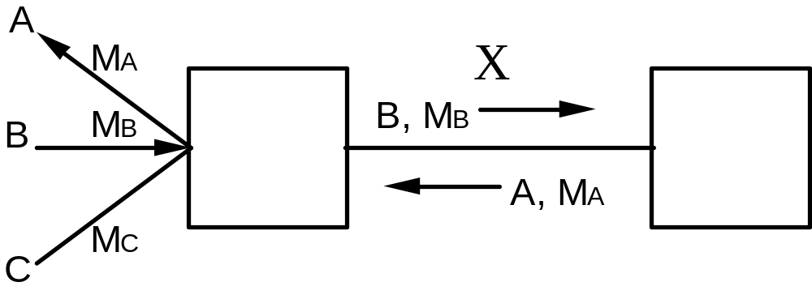

Quoting

A | B A quoting B
A | B says s ≡ A says (B says s)

Axioms
| is associative
| distributes over and, or
A ⇒*⇒A|B A | B

Multiplexing a Channel: Examples

Multiplexer | Main channel | Subchannels | Address
OS | node–node | process–process | port or process ID
Network routing | node–network | node–node | node address

Signed Secure Channels
The channel is defined by the key: If only A knows K–1, then K ⇒ A (Actually, if only A uses K–1, then K ⇒ A)
K says s is a message which K can verify
s

Sign(K⁻¹, s)
}

K says s

K says s

{

Verify(K, s)
s

OK?

The bits of “K says s” can travel on any path

Abstract Cryptography: Sign/Verify
Verify(K, M, sig) = true iff sig = Sign(K', M) and K' = K⁻¹
  - Is sig K’s signature on M?
Concretely, with RSA public key:
  - Sign(K⁻¹, M) = RSAencrypt(K⁻¹, SHA1(M))
  - Verify(K, M, sig) = (SHA1(M) = RSAdecrypt(K, sig))
Concretely, with AES shared key:
  - Sign(K, M) = SHA1(K, SHA1(K || M))
  - Verify(K, M, sig) = ( SHA1(K, SHA1(K || M)) = sig)

Concrete crypto is for experts only!

Abstract Cryptography: Seal/Unseal
Unseal(K⁻¹, Seal(K, M)) = M, and without K⁻¹ you can’t learn anything about M from Seal(K, M)
Concretely, with RSA public key:
  - Seal(K, M) = RSAencrypt(K⁻¹, IV || M)
  - Unseal(K, Msealed) = RSAdecrypt(K, M sealed).M
Concretely, with AES shared key:
  - Seal(K, M) = AESencrypt(K, IV || M)
  - Unseal(K, M sealed) = AESdecrypt(K, M sealed).M

Concrete crypto is for experts only!

Sign and Seal
Normally when sealing must sign as well!
  - Seal(Kseal⁻¹, M || Sign(K sign⁻¹, M))
Often Sign is replaced with a checksum ???
Concrete crypto is for experts only!
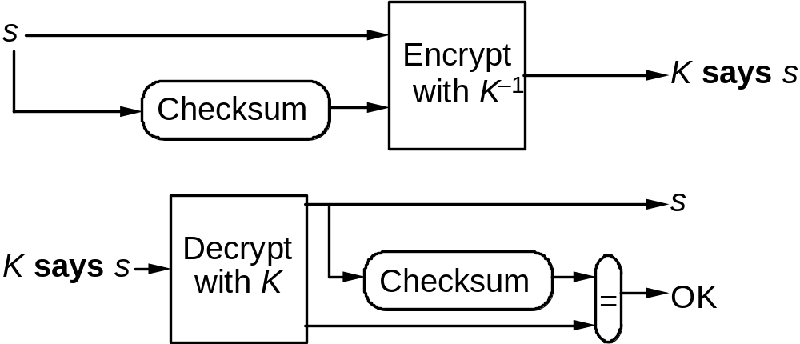

Public Key vs. Shared Key
Public key: K ≠ K⁻¹
  - Broadcast
  - Slow
  - Non-repudiable (only one possible sender)
  - Used for certificates
Key ⇒ name: KIntel says KAlice ⇒ Alice@Intel
Temp key ⇒ key: Ktemp says KSSL ⇒ Ktemp
KAlice says Ktemp ⇒ KAlice
Shared key: K = K⁻¹
  - Point to point
  - Fast
Can simulate public key with trusted on-line server

How Fast is Encryption?
 |  |  | Use | Notes
rsa encrypt | 5 | ms (25 KB/s) | sign | 1000 bit modulus
rsa decrypt | 0.2 | ms (625 KB/s) | verify | Exponent=17
sha-1 | 70 | MBytes/s | sign | hmac
aes | 50 | MBytes/s | seal | 256 bit key

On 2 GHz Pentium, Microsoft Visual C++. Data from Wei Dai at www.cryptopp.com
Might be 2x faster with careful optimization

Fast Encryption in Practice

Want to run at network speed.

How? Put encryption into the data path.
Network interface parses the packet to find a
key identifier and maps it to a key for decryption
Parsing depends on network protocol (e.g., TCP/IP)
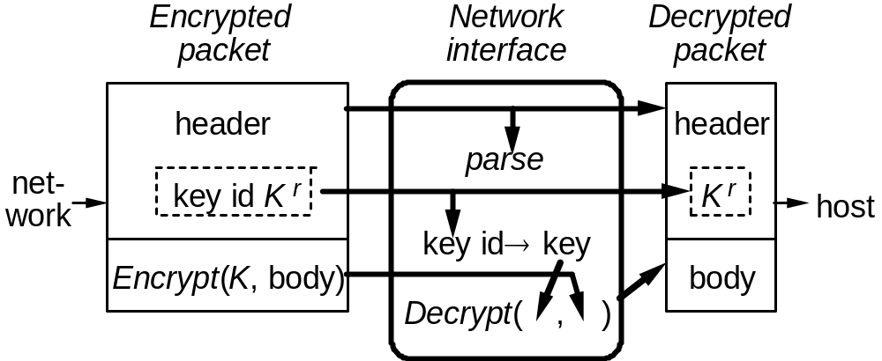

Messages on Encrypted Channels
If K says s, we say that s is signed by K
Sometimes we call “K says s” a certificate
The channel isn’t real-time: K says s is just bits

K says s can be viewed as
• An event: s transmitted on channel K
• A pile of bits which makes sense if you know the decryption key
• A logical formula

Messages vs. Meaning
Standard notation for Seal(Kseal⁻¹, M || Sign(K sign⁻¹, M)) is {M}K. This does not give the meaning
Must parse message bits to get the meaning
  - Need unambiguous language for all K’s messages
  - In practice, this implies version numbers
Meaning could be a logical formula, or English
  - A, B, {K}KCA means C says (to A) “K is a key”. C says nothing about A and B. This is useless
  - {A, B, K}KCA means C says “K is a key for A to talk to B”. C says nothing about when K is valid
  - {A, B, K, T}KCA means C says “K is a key for A to talk to B first issued at time T”

Replay

Encryption doesn’t stop replay of messages.
Receiver must discard duplicates.
This means each message must be unique.
Usually done with sequence numbers.
Receiver must remember last sequence number while the key is valid.

Transport protocols solve the same problem.

Timeliness

Must especially protect authentication against replay
If C says KA ⇒ A to B and Eve records this, she can get B to believe in KA just by replaying C’s message.
Now she can replay A’s commands to B.
If she ever learns KA, even much later, she can also impersonate A.
To avoid this, B needs a way to know that C’s message is not old.
Sequence numbers impractical—too much long-term state.

Timestamps and Nonces

Timestamps
With synchronized clocks, C just adds the time T, saying to B
KC says KA ⇒ A at T

Nonces
Otherwise, B tells C a nonce NB which is new, and C sends to B
KC says KA ⇒ A after NB

NAMES FOR PRINCIPALS
Authorization is to named principals. Users have to read these to check them.
Lampson may read file report
Root names must be defined locally
KIntel ⇒ Intel
From a root you can build a path name
Intel/Alice (= Alice@Intel)
With a suitable root principals can have global names.
/DEC/SRC/Lampson may read file /DEC/SRC/udir/Lampson/report

Authenticating Names
KIntel ⇒ Intel ⇒ Intel/Alice (= Alice@Intel)
Ktemp | ⇒ | KAlice | ⇒ | Alice@Intel | ⇒ ...
 |  | KIntel says
says
K_{SSL}
says
says
Alice’s smart card
Alice’s login system
Spectra
web page
K_{temp}
Alice@Intel
Atom@Microsoft
Microsoft
Intel
K_{Alice}
Spectra ACL

Authenticating a Channel

Authentication — who can send on a channel.
C ⇒ P; C is the channel, P the sender.

Initialization — some such facts are built in: Kca ⇒ CA.

To get new ones, must trust some principal, a certification authority.
Simplest: trust CA to authenticate any name:
CA ⇒ Anybody

Then CA can authenticate channels:
Kca says Kws ⇒ WS
Kca says Kbwl ⇒ bwl

One-Way Authentication
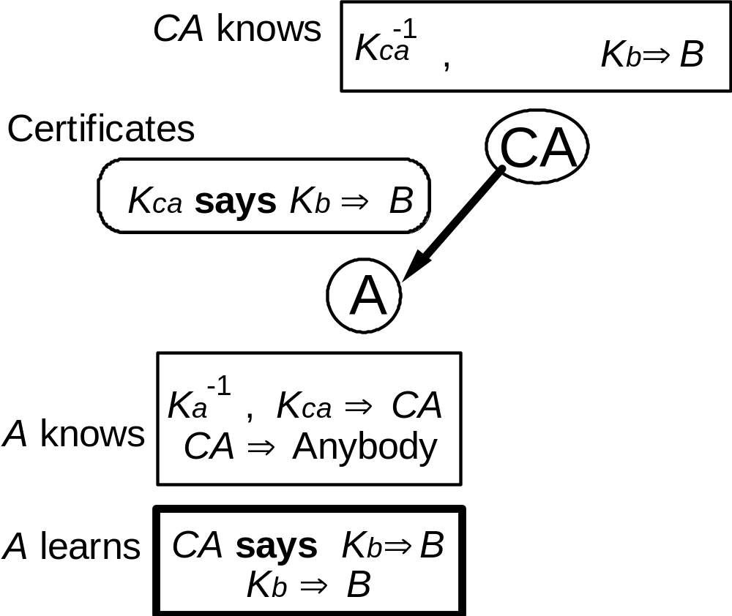

Mutual Authentication
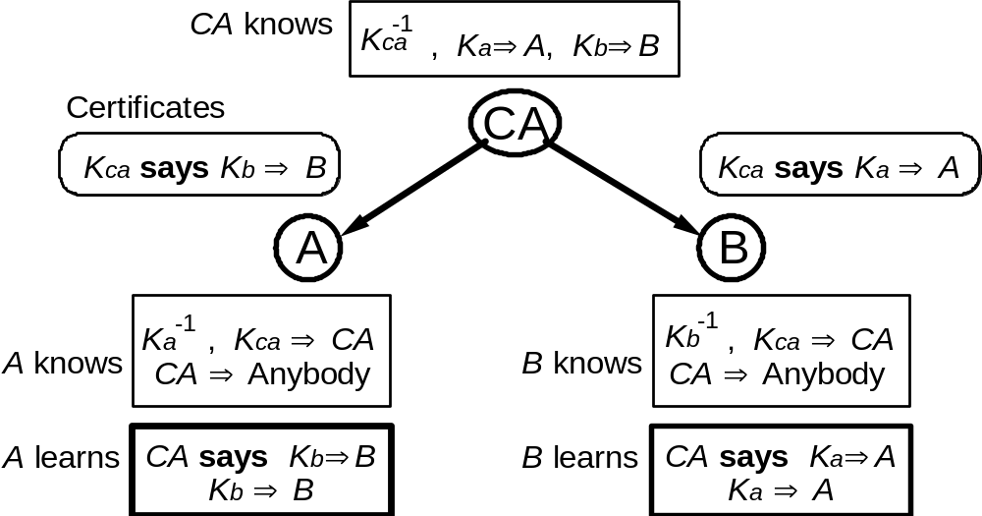
This also works with shared keys, as in Kerberos.

Who Is The CA
“Built In”
CA’s in browsers
  - There are lots
  - Because of politics
  - Look at Tools / Internet options / Content / Publishers /
Trusted root certification authorities
This is a configuration problem

Revocation

Revoke a certificate by making the receiver think it’s invalid.

To do this fast, the source of certificates must be online.
This loses a major advantage of public keys, and reduces security.

Solution: countersigning —
An offline CAassert, highly secure.
An online CArevoke, highly timely.
Both must sign for the certificate to be believed, i.e.,
CAassert and CArevoke ⇒ Anybody

Large-Scale Authentication

A large system can’t have CA ⇒ Anybody.
Instead, must have many CA's, one for each part.

One natural way is based on a naming hierarchy:
A tree of directories with principals as the leaves
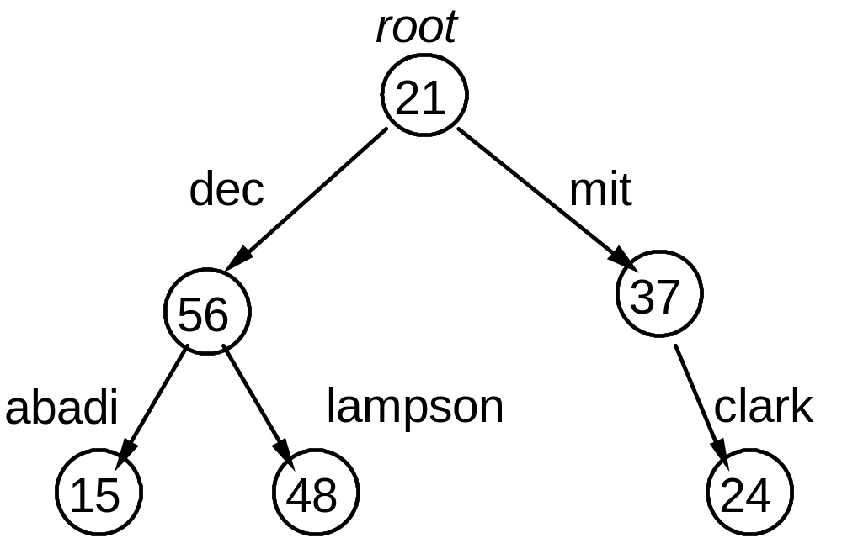

Large-Scale Authentication: Example

Keep trust as local as possible:
Authenticating A to B needs trust only up to
least common ancestor
dec for /dec/lampson → /dec/abadi
root for /dec/lampson → /mit/clark

Rules for Path Names
New operator except:
Informally, P except M can speak for P / N as long as N ≠ M

Axioms
P | except M | ⇒ P
(P | except M) | N | ⇒ P / N except ‘..’ | if N ≠ M | child
(P / N | except M) | ‘..’ | ⇒ P except N | if N ≠ ‘..’ | parent

Effect: Authentication can traverse the tree outward from the starting point, but can never retrace its steps

Rules for Path Names: Example
Start with Clampson ⇒ /dec/lampson except nil known
Clampson says Cdec ⇒ /dec except lampson parent
Cdec says Croot ⇒ / except dec parent
Croot says Cmit ⇒ /mit except “..” child
Cmit says Cclark ⇒ /mit/clark except “..” child
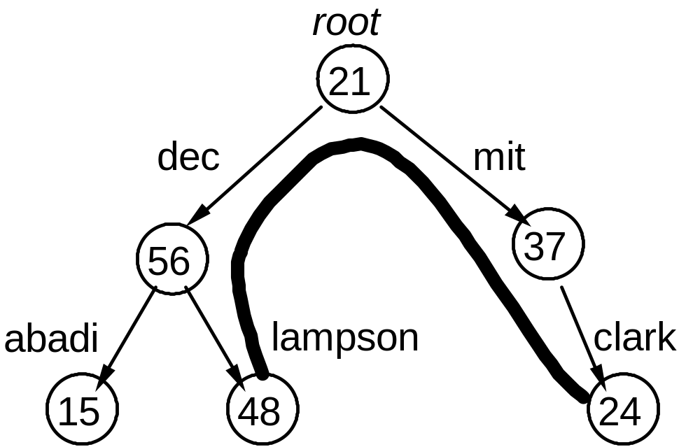

Trusting Fewer Authorities: Cross-Links

For less trust, add links to the tree
Now lampson trusts only dec for
/dec/lampson → /dec/mit/clark
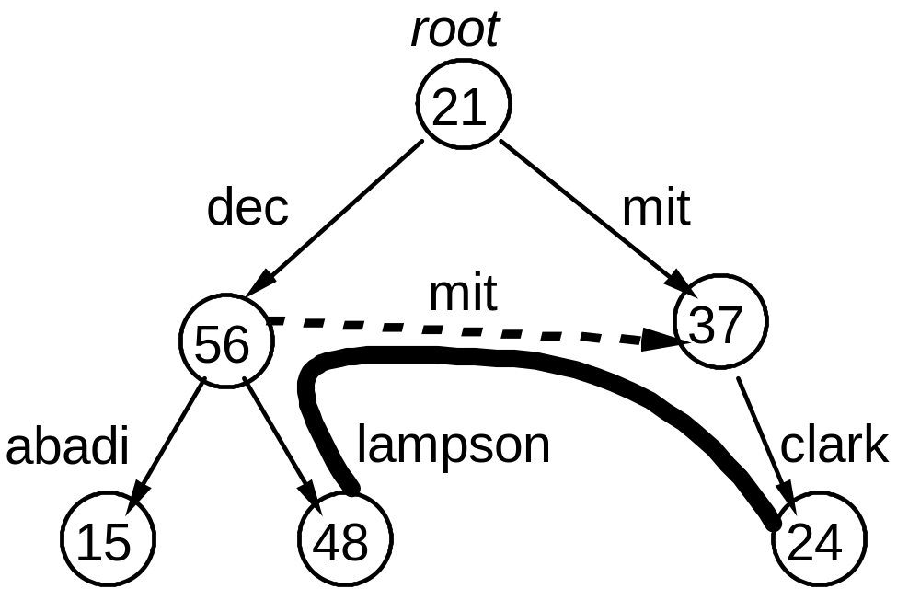

Login
Chain of responsibility:
KSSL | ⇒ | Ktemp | ⇒ | KAlice | ⇒ | Alice@Intel | ⇒ ...
Ktemp says |  | KAlice says
(SSL setup) |  | (via smart card)
says
K_{SSL}
says
says
Alice’s smart card
Alice’s login system
Spectra
web page
K_{temp}
Alice@Intel
Atom@Microsoft
Microsoft
Intel
K_{Alice}
Spectra ACL

Authenticating Users

Goals
Hide the secret that authenticates the user
Authenticate without disclosing it
Let a node N speak for the user: N ⇒ Alice

Method
KAlice ⇒ Alice
KAlice says N ⇒ Alice
KAlice–1 is the user’s secret
It can be stored encrypted by her password,
or better, held inside a smart card.

Identifying Nodes for Login Delegation
Usually a workstation has no permanent identity
  - Not true for servers
  - Workstation might have a “meets ITG policy” identity
Need a temporary principal for Alice to delegate to at login
Generate login session key Ktemp

User Credentials
CA generates:
  - user key: KAlice–1
  - child certificate: KCA says KAlice ⇒ Alice
Certificate is public
Where to keep KAlice–1?
  - Smart card
  - Encrypted by password
  - On a server

Server-mediated Login
Workstation talks to login server
Server confining user’s presence
  - Password
  - One-time password
  - Time-varying password
  - Smart card
  - Biometrics

Two-factor Authentication
Problems with passwords
Advantages of physical “tokens”
What if token is stolen?
Combine token and something tied to user
  - Password / PIN
  - Biometrics
Problem with passwords: exhaustive search
Problems with biometrics: not secret, can’t change

Login with Node Identity
Check Kca says KAlice ⇒ Alice
Generate Ktemp –1, a login session key.
Delegate to session key K temp and node key Kn
KAlice says (Ktemp and Kn) ⇒ KAlice
Then the session key countersigns with a short timeout, say 30 minutes:
Ktemp says Kn ⇒ Ktemp
OS discards Ktemp –1 at logout, and the delegation expires within 30 minutes.

GROUPS and Group Credentials

Defining groups: A group is a principal; its members speak for it
Alice@Intel ⇒ Atom@Microsoft
Bob@Microsoft ⇒ Atom@Microsoft
. . .

Proving group membership: Use certificates
K Microsoft says Alice@Intel ⇒ Atom@Microsoft

Authenticating Groups
KMicrosoft ⇒ Microsoft Þ Atom@Microsoft
... ⇒ | KAlice | ⇒ | Alice@Intel | ⇒ | Atom@Microsoft | ⇒ ...
 |  |  | KMicrosoft says
says
K_{SSL}
says
says
Alice’s smart card
Alice’s login system
Spectra
web page
K_{temp}
Alice@Intel
Atom@Microsoft
Microsoft
Intel
K_{Alice}
Spectra ACL

What Is A Group
Set of principals
  - Alice@Intel ⇒ Atom@Microsoft
Principals with some property
  - Resident over 21 years old
  - Type-checked program
Can think of the group (or property) as an attribute of each principal that is a member

Certifying Properties
Need a trusted authority: CA ⇒ typesafe
  - Actually KMS says CA ⇒ KMS / typesafe
Usually done manually
Can also be done by a program P
  - A compiler
  - A class loader
  - A more general proof checker
Logic is the same: P ⇒ typesafe
  - Someone must authorize the program:
  - KMS says P ⇒ KMS / typesafe

Groups As Parameters
An application may have some “built-in” groups
Example: In an enterprise app, each division has
  - groups: manager, employees, finance, marketing
  - folders: budget, advertising plans, ...
Thus, the steel division is an instance of this, with
  - steelMgr, steelEmps, steelFinance, steelMarketing
  - folders: steelBudget, steelAdplans, ...

P and Q: Separation of Duty
Often we want two authorities for something.
A and B says s = (A says s) ∧ (B says s)
We use a compound principal with and to express this:
Lampson and Taylor two users
Lampson and Ingres user running an application
CAassert and CArevoke online and offline CAs

P or Q: Weakening
Sometimes want to weaken a principal
A or B says s = (A says s) ∨ (B says s)
  - A ∨ B says “read f ” needs both A⇒R f and B⇒R f
  - Example: Java rule—callee ⇒ caller ∨ callee-code
  - Example: NT restricted tokens—if process P is running untrusted-code for blampson then
P ⇒ blampson ∨ untrusted-code

P as R: Roles
To limit its authority, a principal can assume a role.
People assume roles: Lampson as Professor
Machines assume roles as nodes by running OS programs: Vax#1724 as bsd4.3a4 = Jumbo
Nodes assume roles as servers by running services:
Jumbo as SRC-NFS

Metaphor: a role is a program
Encoding: A as R ≡ A | R if R is a role
Axioms: A ⇒*⇒A|R A as R if R is a role

B for A: Melding

B for A: B acting on behalf of A
Workstation22 for Lampson
Ingres for Lampson

Axiom: (A | B) and (B | A) ⇒ B for A

To delegate —
A offers: A | B says B | A ⇒ B for A
B accepts: B | A says B | A ⇒ B for A
Together: (A | B and B | A) says B | A ⇒ B for A
Final delegation: B | A ⇒ B for A

Using a Meld
Suppose the ACL for file foo says
SRC-WS for Lampson may read “foo”
If we know WS22 ⇒ SRC-WS
then WS22 for Lampson may read “foo”

Meld Example: Login Credentials
Get Kbwl–1 from Encrypt(PW, Kbwl–1) with user’s password
Check Kca says Kbwl ⇒ bwl
Offer meld to node key Kn:
Kbwl | Kn says Kn ⇒ (Kws as Taos) for Kbwl
Node accepts meld (given Kn ⇒ Kws as Taos):
Kn | Kbwl says Kn ⇒ (Kws as Taos) for Kbwl
And from the for axiom & handoff
Kn ⇒ (Kws as Taos) for Kbwl

An Example

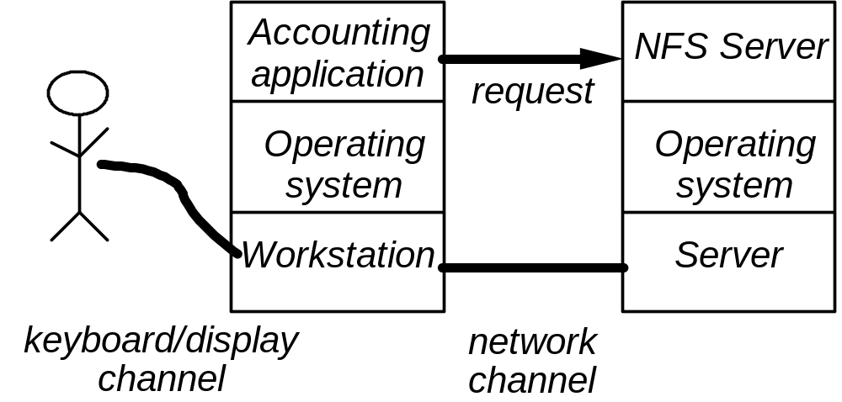

Example: Details
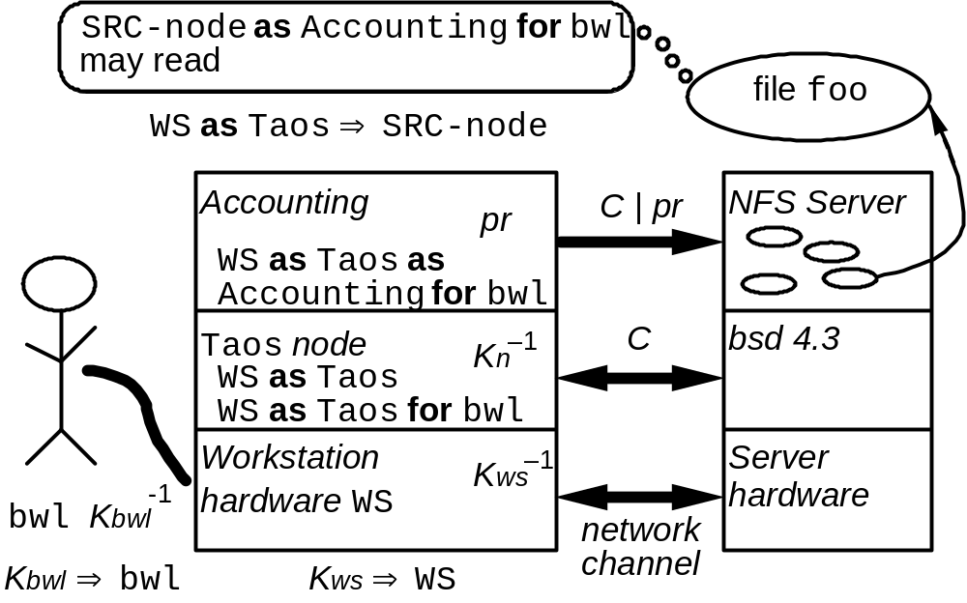

AUTHENTICATING SYSTEMS: Loading
A digest X can authenticate a program SQL:
  - KMicrosoft says “If image I has digest X then I is SQL”
formally X ⇒ KMicrosoft / SQL
  - This is just like KAlice ⇒ Alice@Intel
But a program isn’t a principal: it can’t say things
To become a principal, a program must be loaded into a host H
  - Booting is a special case of loading
X ⇒ SQL makes H
  - want to run I if H likes SQL
  - willing to assert that SQL is running

Authenticating Systems: Roles
A loaded program depends on the host it runs on.
  - We write H as SQL for SQL running on H
  - H as SQL says s = H says SQL says s
H can’t prove that it’s running SQL
But H can be trusted to run SQL
  - KTCS says H as SQL ⇒ KTCS / SQL
This lets H convince others that it’s running SQL
  - H says C ⇒ KTCS / SQL

Node Credentials
Machine has some things accessible at boot time.
A secret Kws–1 A trusted CA key Kca
Boot code does this:
Reads Kws–1 and then makes it unreadable.
Reads boot image and computes digest Xtaos.
Checks Kca says Xtaos ⇒ Taos.
Generates Kn–1, the node key.
Signs credentials Kws says Kn ⇒ Kws as Taos
Gives image Kn–1 , Kca , credentials, but not Kws–1.
Other systems are similar: Kws as Taos as Accounting

Node Credentials: Example

Example: Server’s Access Control
Kws says Kn ⇒ Kws as Taos | node | credentials
Kbwl says Kn ⇒  (Kws as Taos) for Kbwl | login session
Kn says C ⇒ Kn | channel
C says C | pr ⇒ (Kws as Taos as Accounting) for Kbwl | process
C | pr says “read file foo” |  | request

Sealed Storage: Load and Unseal
Instead of authenticating a new key for a loaded system,
  - Kws says Kn ⇒ Kws as Taos
Unseal an existing key
  - SK = Seal(KWSseal⁻¹, < ACL: Taos, Stuff: KTaosOnWS⁻¹>)
  - Save(ACL: Taos, Stuff: KTaosOnWS⁻¹>) returns SK
  - Open(SK) returns KTaosOnWS⁻¹if caller ⇒ Taos

Assurance: NGSCB (Palladium)
A cheap, convenient, “physically” separate machine
A high-assurance OS stack (we hope)
A systematic notion of program identity
  - Identity = digest of (code image + parameters)
Can abstract this: KMS says digest ⇒ KMS / SQL
  - Host certifies the running program’s identity:
H says K ⇒ H as P
  - Host grants the program access to sealed data
H seals (data, ACL) with its own secret key
H will unseal for P if P is on the ACL

NGSCB Hardware
Protected memory for separate VMs
Unique key for hardware
Random number generator
Hardware attests to loaded software
Hardware seals and unseals storage
Secure channels to keyboard, display

NGSCB Issues
Privacy: Hardware key must be certified by manufacturer
  - Use Kws to get one or more certified, anonymous keys from a trusted third party
  - Use zero-knowledge proof that you know a mfg-certified key
Upgrade: v7of SQL needs access to v6 secrets
  - v6 signs “v7 ⇒ v6”
  - or, both ⇒ SQL
Threat model: Other software
  - Won’t withstand hardware attacks

NGSCB Applications
Keep keys secure
Network logon
Authenticating server
Authorizing transactions
Digital signing
Digital rights management

Need app TCB: factor app into
  - a complicated , secure part that runs on Windows
  - a simple, secure part that runs on NGSCB

AUTHORIZATION in Access Control
Guards control access to valued resources.

Structure the system as —
Objects entities with state.
Principals can request operations
on objects.
Operations how subjects read or change objects.
Reference monitor

Object
Do
operation
Resource
Principal
Guard
Request
Source
Audit log
Authentication
Authorization

Authorization Rules

Rules control the operations allowed
for each principal and object.

Principal may do | Operation on | Object
Taylor | Read | File “Raises”
Lampson | Send “Hello” | Terminal 23
Process 1274 | Rewind | Tape unit 7
Schwarzkopf | Fire three shots | Bow gun
Jones | Pay invoice 432 | Account Q34

Access Matrix
 | File Raises | Account Q34 | Tape unit 7
Lampson | read | deposit
Process 1274 | read/write |  | r/w/rewind
Finance dept |  | deposit/ withdraw

Representing the Access Matrix
 | Capability
  O1 | O2 | O3
  P1 | T11 | T12
  P2 | T21 |  | T23
  P3 |  | T32
ACL

Prefer ACLs for long-tem authorization
  - Usually need to audit who can access a resource
Capabilities are fine as a short-term cache
  - OS file descriptors for open files

Authorization with ACLs
View a resource object O as a principal
P on O’s ACL means P can speak for O
  - Permissions limit the set of things P can say for O
If Spectra’s ACL says Atom can r/w, that means
Spectra says Atom@Microsoft ⇒r/w Spectra
says
K_{SSL}
says
says
Alice’s smart card
Alice’s login system
Spectra
web page
K_{temp}
Alice@Intel
Atom@Microsoft
Microsoft
Intel
K_{Alice}
Spectra ACL

Access Control Lists (ACLs)
Object O’s ACL says: principal P may access O.
Lampson may read and write O
(Jumbo for SRC) may append to O
ACLs need named principals so people can read them.
Checking access:
Given a request Q says read O
an acl P may read/write O
Check that Q speaks for P Q ⇒ P
rights suffice read/write ≥ read

Permissions

Principal A speaks for B about T A ⇒T B
If A says something in set T, B does too:
Thus, A is stronger than B, or responsible for B, about T
  - Precisely: (A says s) ∧ (s ∈ T) implies (B says s)
Permissions represent sets of statements
  - P may read/write O = P ⇒r/w O
Traditionally they appear only in ACLs, not in delegations, which are unrestricted

T can specify some objects and some of their methods

Expressing sets of statements.
SDSI / SPKI uses “tags” to define sets of statements
A tag is a regular expression, that is, a set of strings
The object interprets a string as a set of statements
  - Read(*.doc) = reads of files named *.doc
  - < 5000 = purchase orders less than $5000
Also can express unions and intersections of sets
  - Read(*.doc) and < 5000
Expressive T allows bigger objects: a single permission for all .doc files

Transitivity: Intersecting Sets
If A ⇒T B and B ⇒U C then A ⇒T∩U C
Why?
A ⇒T B ≡ (A says s) ∧ (s ∈ T) implies (B says s)
B ⇒U C ≡ (B says s) ∧ (s ∈ U) implies (C says s)
How to implement set intersection ?
  - Might be able to simplify the expression
  - Always can test s against both T and U

Pragmatics
Authorization must be
  - set up
  - later checked for correctness
  - changed as life goes on
This works best when the authorization data is small and simple
But, want to authorize the “least privilege” needed to get the job done

Conflict. Who wins?

Keeping Authorization Simple
ACLs on large sets of resources
  - Big subtrees of the file system
  - Large sets of web sites
Usually for groups, principals that have some property, such as “Microsoft employee” or “type-safe” or “safe for scripting”

IMPLEMENTATION

Process Credentials
Make a node-to-node channel C = des(Ksr) using shared key encryption.
Establishing Ksr yields C ⇒ Kn.
The OS multiplexes this single channel among processes.
The OS issues credentials for the subchannels C | pr.
More multiplexing lets a process speak for several principals.

API for Authentication
Prin represents principals, with a subtype Auth for that a process can speak for
AID is an Auth identifier, a byte string
Authenticating messages
GetChan(dest:Address): Chan;
GetAID(p:Auth): AID;
Send(dest:Chan; m:Msg);
Receive(): (Chan, Msg);
GetPrin(c:Chan; aid:AID): Prin;
RPC marshals an Auth parameter and unmarshals an aid automatically, thus hiding all these procedures

API for Authentication (2)
Authorization
Check(acl:ACL; p:Prin): BOOL
Managing principals
Inheritance(): ARRAY OF Auth;
Login (name, password: TEXT): Auth;
AdoptRole(a:Auth; role:TEXT): Auth;
Offer (a:Auth; b:Prin): Auth;
Claim(b:Auth; meld:Prin): Auth;
Discard(a:Auth; all:BOOL);

API for Melding
Offer (a:Auth; b:Prin): Auth;
Claim(b:Auth; meld :Prin): Auth;
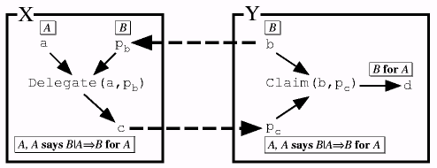
Offer

Implementation Internals
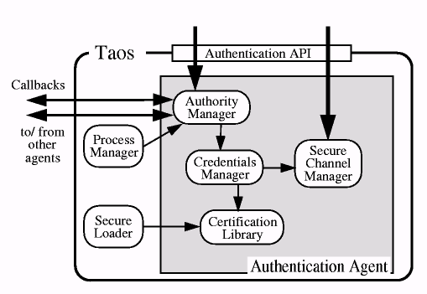

Secure Channel, Authority Managers
The secure channel manager creates process-to-process secure channels.
TYPE ChanID = { nk:KeyDigest; pr:INT; addr:Address };
GetChanID(ch:Chan): ChanID;
PTagFromChan(c:ChanID): PTag;

The authority manager associates Auths with processes and handles authentication requests.
TYPE PrinID = { ch:ChanID; aid:AID };
Delegate(a:Auth; ptag:PTag);
PurgePTag(ptag: PTag);

Credentials Manager
Maintains credentials for local processes and validates certificates from other nodes.

TYPE Cred = TEXT, CredT = ...;
New(name, password: TEXT): CredT;
AdoptRole(t:CredT; role: TEXT): CredT;
Sign(t:CredT; p:PrinID): Cred;
Validate(cr:Cred; p:PrinID): TEXT;
Extract(cr:Cred): Cred;
SignMeld(t:CredT; cr:Cred): Cred;
ClaimMeld(t:CredT; cr:Cred): CredT;

Certification Library
Establishes a trusted mapping between principal names and keys, and between groups and their members.

CheckKey(name:TEXT; k:Key): BOOL;
IsMember(name, group: TEXT): BOOL;
CheckImage(d:Digest; prog, cert: TEXT);

Interfaces to Authentication

There are two styles:

Implicit in communication
Authenticate at connection establishment; a client can find out the principal that the connection speaks for.
Authenticate as part of a remote procedure call; the procedure can find the principal the caller speaks for.

Explicit
Pass the sending principal explicitly in every message.
More flexible: can pass more than one principal.

Either way abstracts authentication protocol details.
The interface just tell you the authenticated principal.

Implementing Authentication: Push vs. Pull

Two ways for receiver B to authenticate sender A:

Push credentials: sender to receiver (Windows SIDs):
A sends B credentials of channel C: proof that C ⇒ A.

Pull credentials: receiver from sender (ACLs, Taos):
A just sends to B on C. B calls back to A to get credentials. B may cache them

Variations
A pushes part of the credentials, and B pulls the rest.
B gets part of the credentials from A, stores part himself, and gets part from network services.

Pull Authentication: Example
Process pr sends on C | pr; OS multiplexes C.
Receiver’s auth agent asks for C | pr credentials.
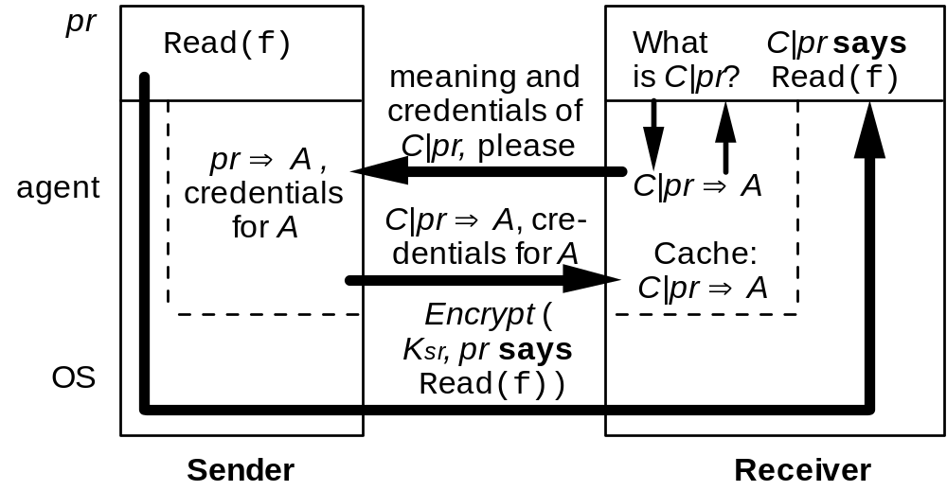

Abbreviations
Extend pull to names:
  - Sender has some long names for principals
  - Choose a short (integer, byte string) abbreviation for each name
    - AID is an example
  - Send the short name; if receiver doesn’t know its definition, it calls back to pull it over
Short names must not be reused
Receiver can discard its short name cache anytime
  - It will be refreshed by pull if needed

Example: Details

The Example Reviewed
Kws says Kn ⇒ Kws as Taos | node | credentials
Kbwl says Kn ⇒  (Kws as Taos) for Kbwl | login session
Kn says C ⇒ Kn | channel
C says C | pr ⇒ (Kws as Taos as Accounting) for Kbwl | process
C | pr says “read file foo” |  | request

Bytes vs. Secure Data
Can choose the the flow and storage of encrypted bytes optimize
  - simplicity
  - performance
  - availability.
Public key = off-line broadcast channel.
  - Write certificate on a tightly secured offline system
  - Store it in untrusted system; anyone can verify it.
Certificates are secure answers to pre-determined queries, (for example, “What is Alice’s key?”) not magic.
  - It’s the same to query an on-line secure database (say Kerberos KDC) over a secure channel

Caching Secure Data
Caching can greatly improve performance
It doesn’t affect security or availability
  - as long as there’s always a way to reload the cache if gets cleared or invalidated

Auditing

Checking access:
Given a request Q says read O
an ACL P may read/write O
Check that Q speaks for P Q ⇒ P
rights are enough read/write ≥ read

Auditing
Each step is justified by
a signed statement, or
a rule

Implement: Tools and Assurance

Services — tools for implementation
Authentication Who said it?
Authorization Who is trusted?
Auditing What happened?

Trusted computing base
Keep it small and simple
Validate each component carefully

The “Speaks for” Relation ⇒

Principal A speaks for B about T A ⇒T B
If A says something in set T, B does too:
Thus, A is stronger than B, or responsible for B, about T
Precisely: (A says s) ∧ (s ∈ T) implies (B says s)
These are the links in the chain of responsibility

Examples
Alice ⇒ Atom group of people
Key #7438 ⇒ Alice key for Alice

Chain of responsibility
Alice at Intel, working on Atom, connects to Spectra, Atom’s web page, with SSL
Chain of responsibility:
K_{SSL} ⇒ K_{temp} ⇒ K_{Alice}
⇒ Alice@Intel ⇒ Atom@Microsoft ⇒ Spectra
says
K_{SSL}
says
says
Alice’s smart card
Alice’s login system
Spectra
web page
K_{temp}
Alice@Intel
Atom@Microsoft
Microsoft
Intel
K_{Alice}
Spectra ACL

References
Look at my web page for these: research.microsoft.com/lampson
Computer security in the real world. At ACSAC 2000. A shorter version is in IEEE Computer, June 2004
Authentication in distributed systems: Theory and practice. ACM Trans. Computer Sys. 10, 4 (Nov. 1992)
Authentication in the Taos operating system. ACM Trans. Computer Systems 12, 1 (Feb. 1994)
SDSI—A Simple Distributed Security Infrastructure, Butler W. Lampson and Ronald L. Rivest.

References
Jon Howell and David Kotz. End-to-end authorization. In Proc. OSDI 2000
Paul England et al. A Trusted Open Platform, IEEE Computer, July 2003

Ross Anderson—www.cl.cam.ac.uk/users/rja14
Bruce Schneier—Secrets and Lies
Kevin Mitnick—The Art of Deception

K_{Alice}

